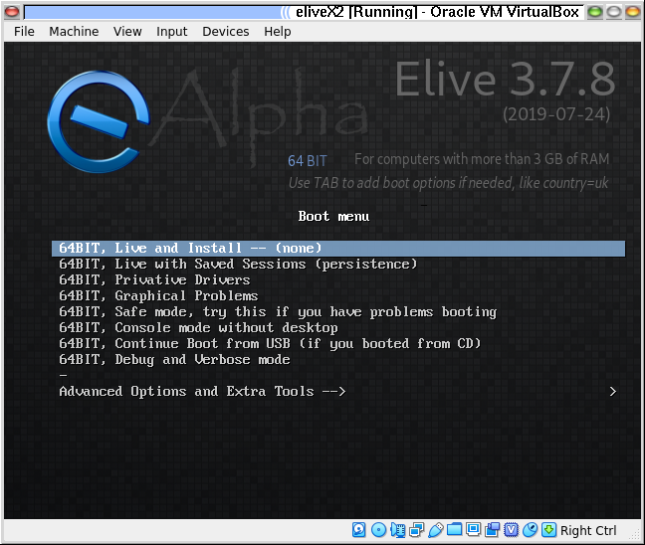
Installing Elive x64 next to an existing 32 bit OS

Sometimes one doesn’t want to upgrade an existing installation for a multitude of resasons. For me the main reason would be to lose my E17 desktop and especially some personal settings.
I had previously migrated an existing Linux-Lite install with an earlier version of Elive X64 so the repartitioning wasn’t needed. If there had been another Linux OS there, the installer would have offered a migration as an option but that’s for another How-to.
So let’s boot off the USB disk by, in my case hitting F12 and getting the boot options for my machine.
NB. This did require me to turn off Secure Boot in my BIOS.
On boot we are presented with the Live Boot options.

Most entries are self explanatory in my view but I’ll try to explain them anyway.
- The default is your best option usually and simply boots a live instance of Elive. The “install” part comes at a later stage and is optional.
- The persistence option is exactly that and allows for keeping a personalized version and data. It will only work if opted for in a second or third boot-up due to the fact that the first time there’s nothing to save.
- Privative drivers refer to non-free drivers for certain GPUs like the Nvidia ones.
- Graphical problems is just that. If you get a persistent black or strange screen try that option.
- The others I think don’t need any explanation except maybe the advanced options but that would be out of scope for this How-to.
So:

Boot her up!
You will be welcomed by this screen explaining the beta-status of the current version. I strongly suggest reading all pop-ups before clicking them away
Beta versions tend to differ to what is usually offered in the way of installation and results.
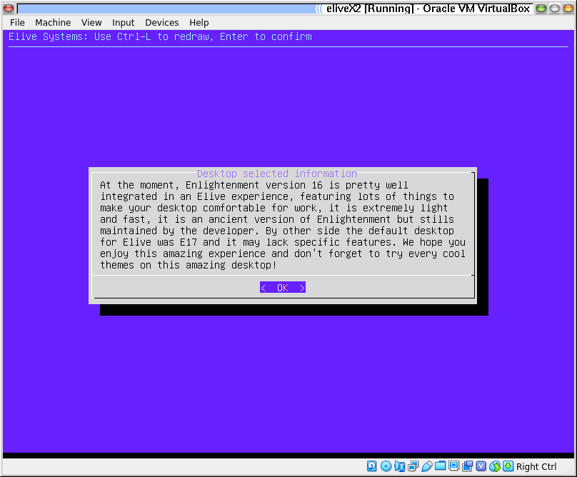
After which we are greeted with the next screen indicating the Desktop.
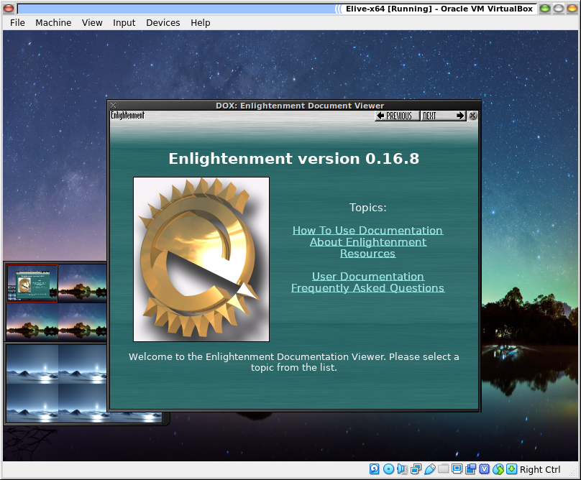

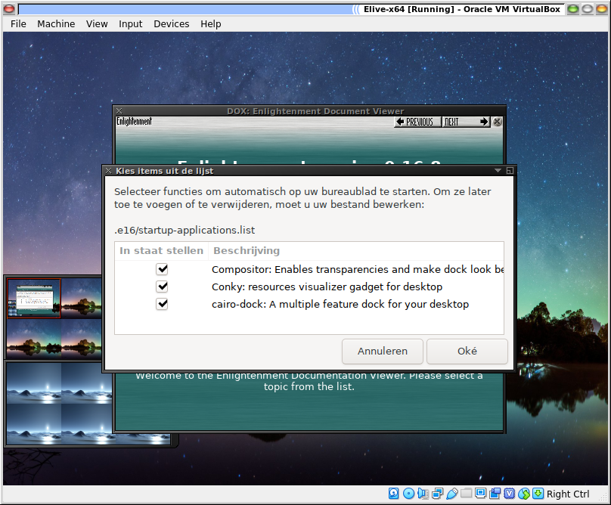
Where a few questions about running your new Desktop are asked. Remember these are not questions about an installation to your HD only to configure the “Live” desktop. Be aware however, that In a later stage, when installing to HD, these settings will be used as your preferred settings.
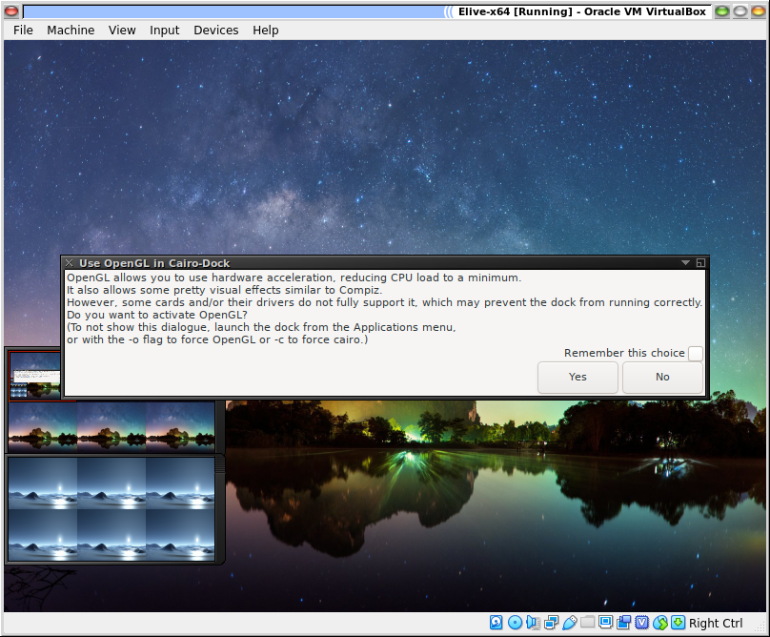
I recommend using the Cairo-dock option as it will give you more control over the desktop without having to search through application menus.
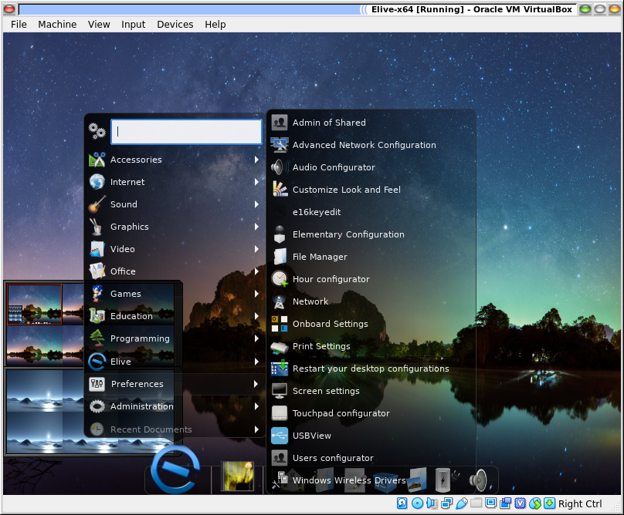
Feel very free to rummage around and set everything to your personal liking.
After a while you will be confronted with a pop-up asking if you want install or continue testing in live mode.
You will always have to option to install through the application menu in the “Elive” section, so don’t feel pressed. Keep playing around or opt for a donation
to Elive, if you haven’t already.

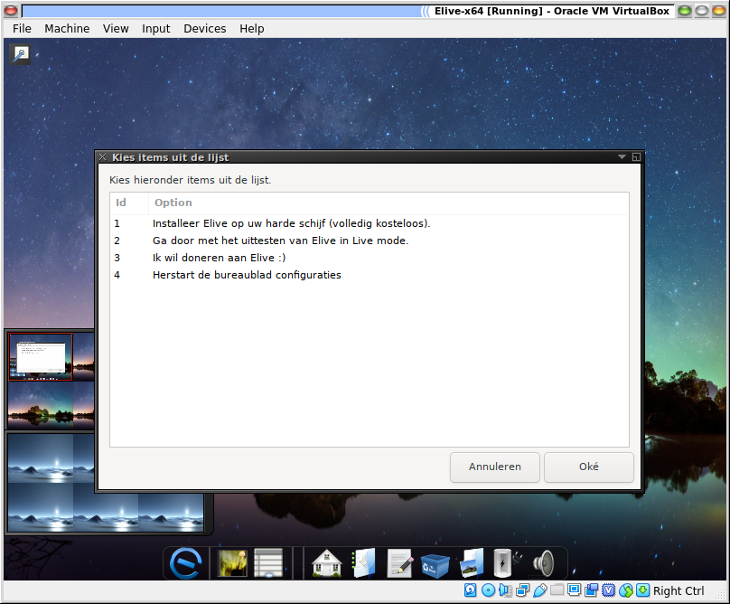
Which takes us to the next phase.

The Installation Routine

When starting the installer you will get the following screen.
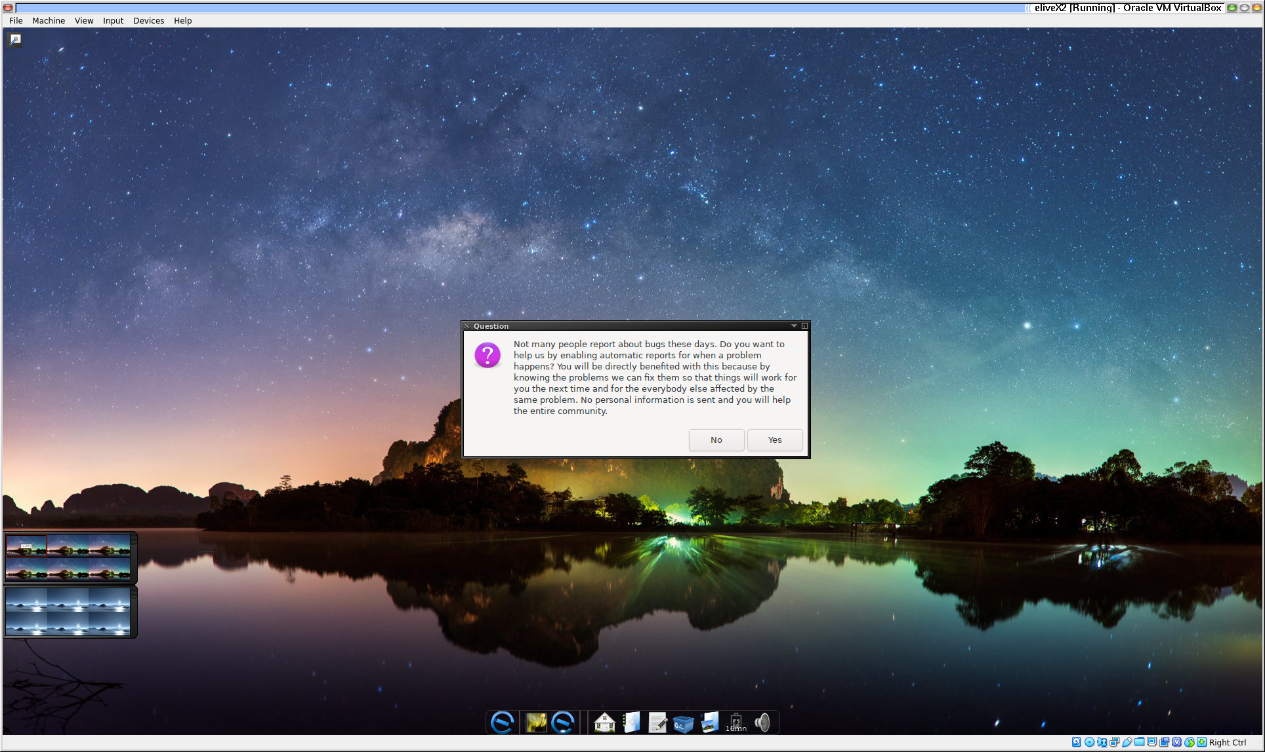
Which is actually a very important one for Elive. It asks if you would enable giving feedback to Elive on how the installation progressed and in the eventuality of mayhem, find out what went wrong. Thus helping others by reporting.
For that you will be asked to enter your email address so as to be able to find it again later. It also helps to take note of the date and hour for later reference.
You well then be asked if you want to upgrade the existing Elive installation, which we don’t so we will then be offered the options available.
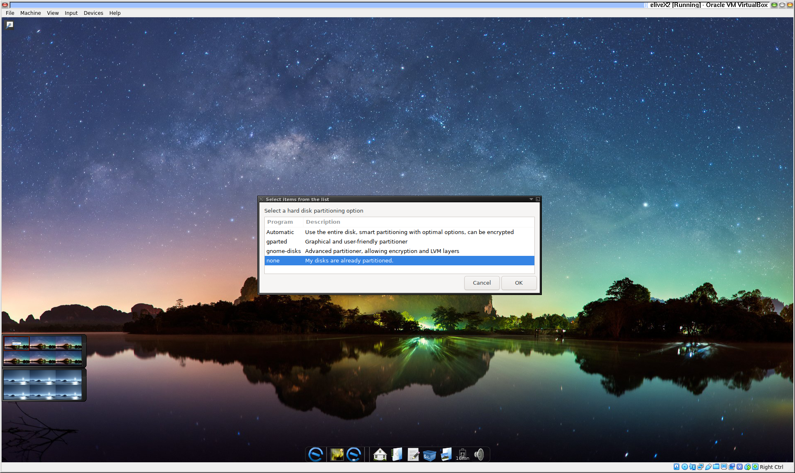
Where we will opt for using the existing partitions.
That will lead us to the next screen that offers all the available partitions.
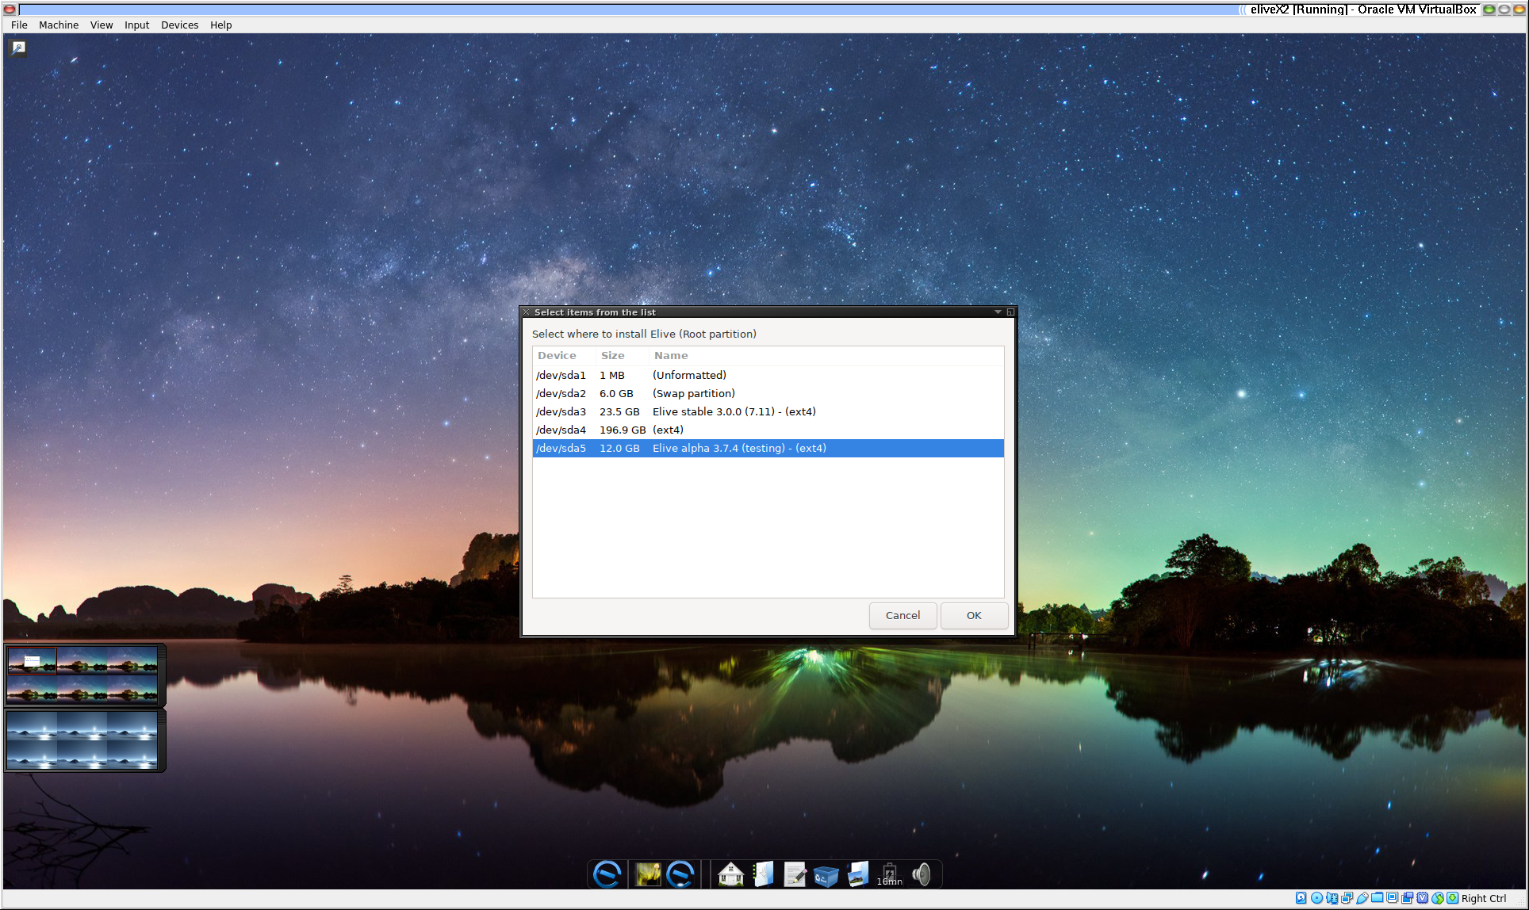
Where in this case we will leave the stable Elive for what it is and go for the 3.7.6 partition (or whichever one is on your machine).
Which will raise the question to which filesystem we want to use.
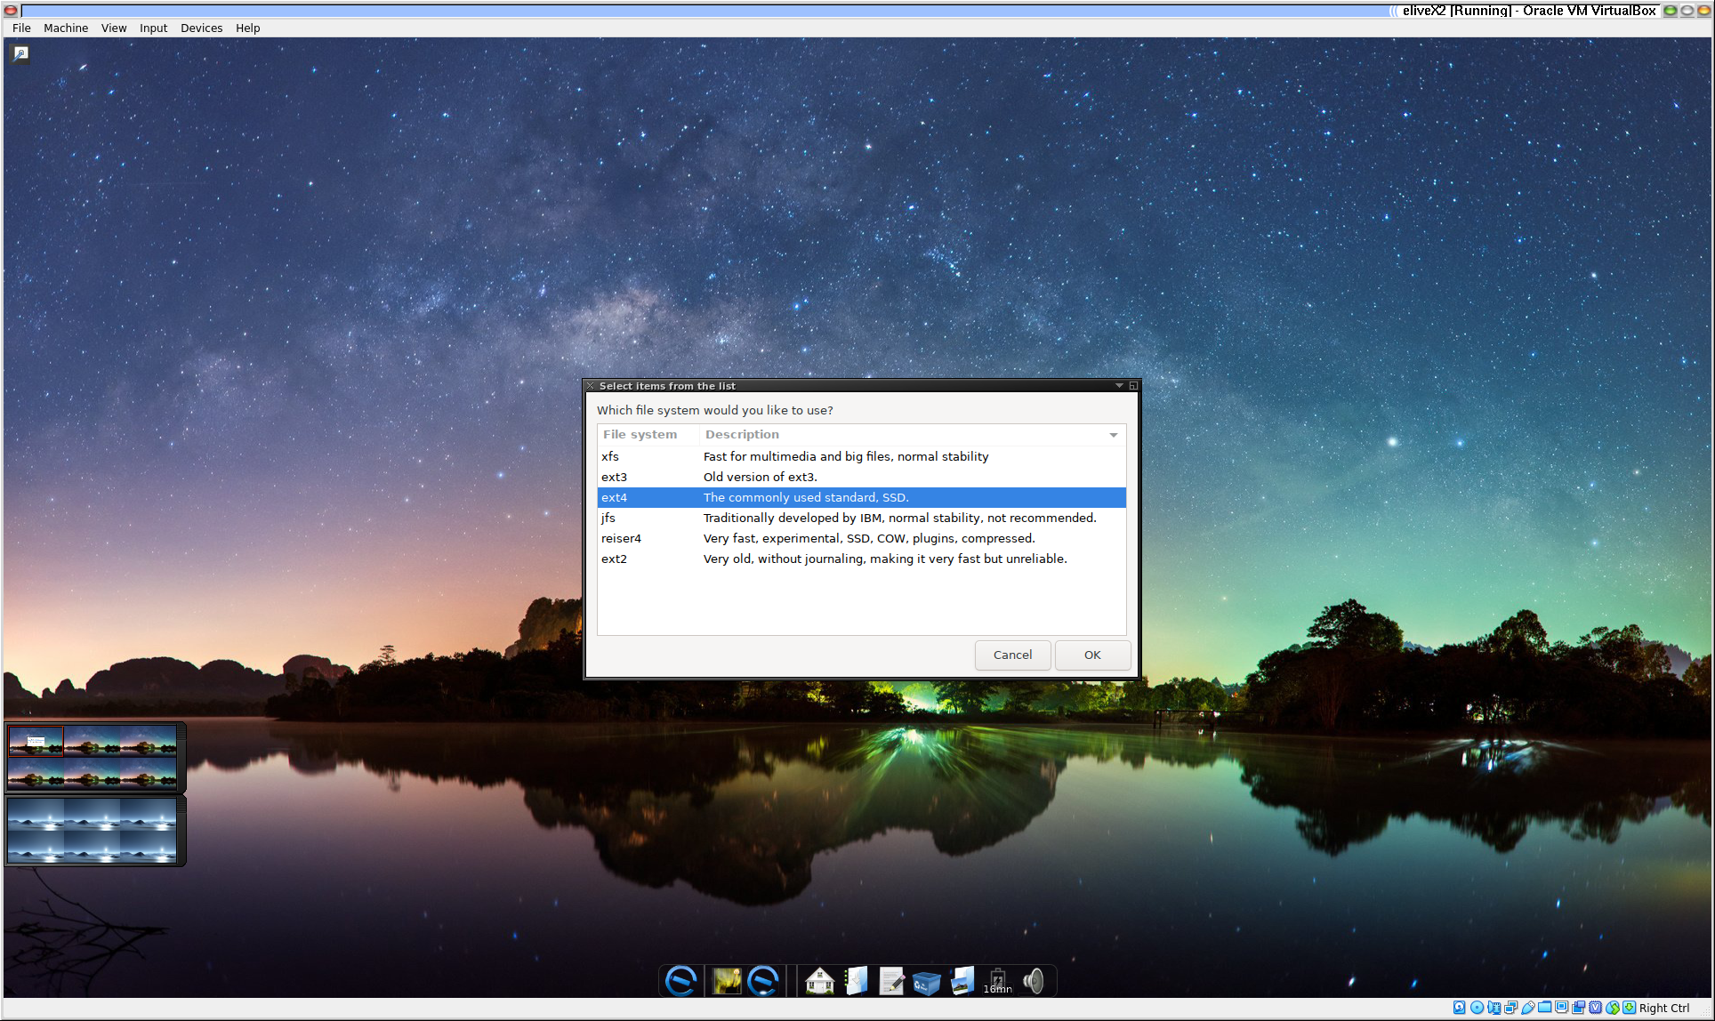
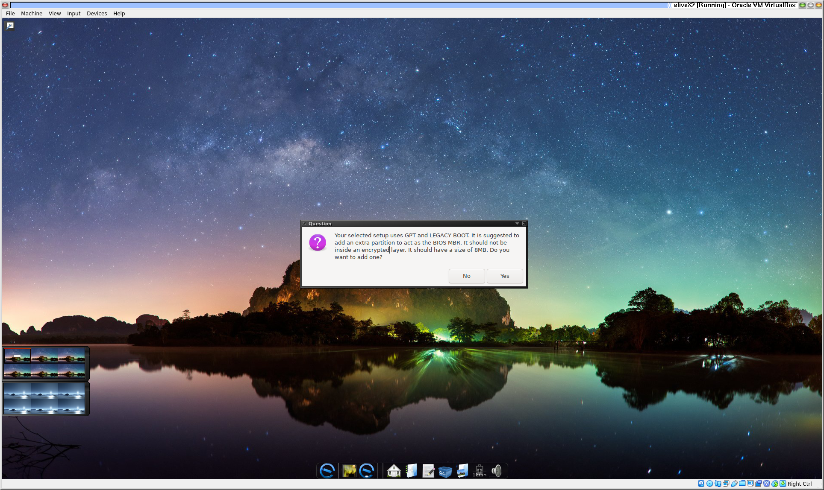
After a warning, the filesystem will be set and the existing partition erased and formatted. Which will then ask if you want to add more partitions like one for /home or /opt but as seen in the screen before, our options are limited.
Then comes a part which can have consequences. Depending on the previous installation there and how you booted up. In my case there is no room for another (even a small 8 Mb) partition at the beginning of the disk without messing with the stable Elive there. So I opt for “No” and carry on installing.
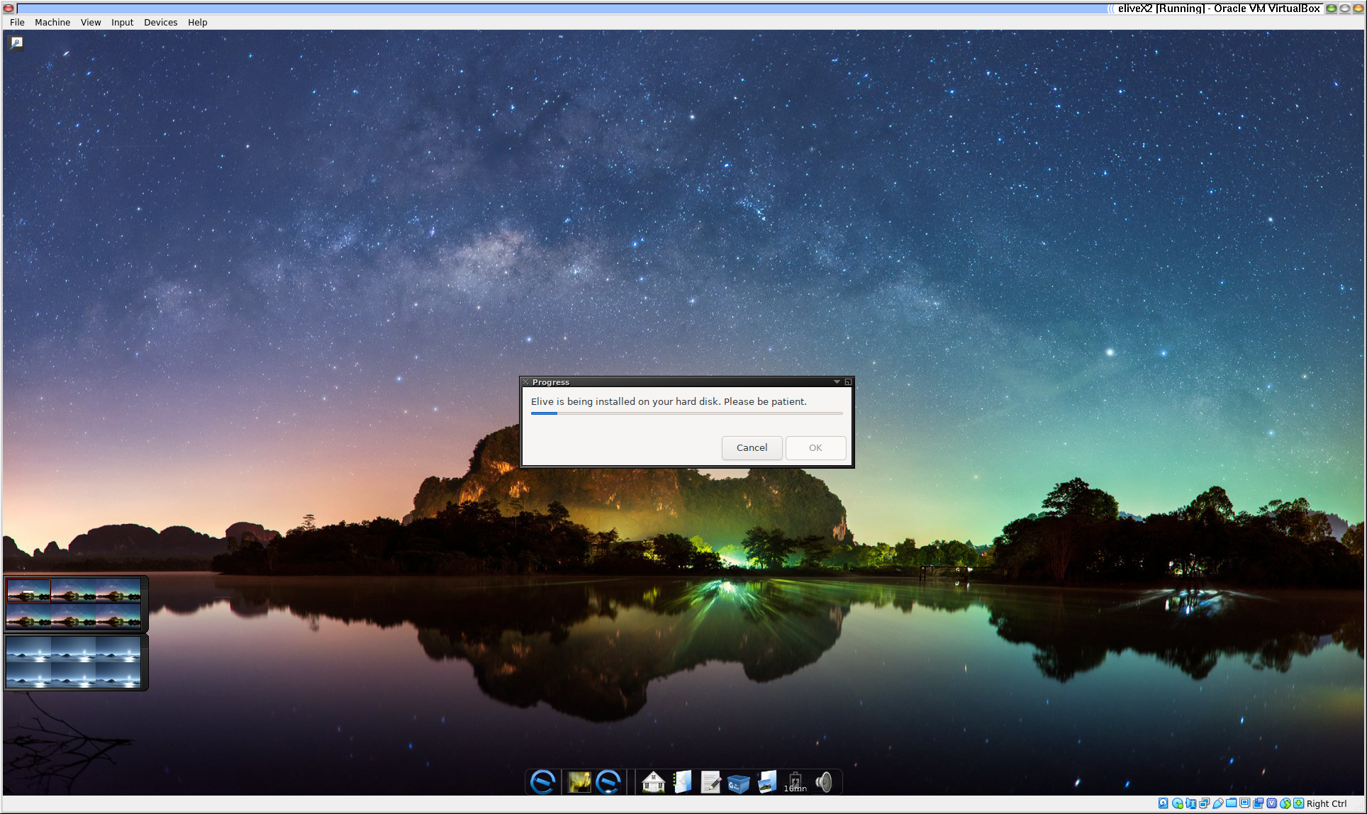
And we get asked some questions about needed drivers and software options.

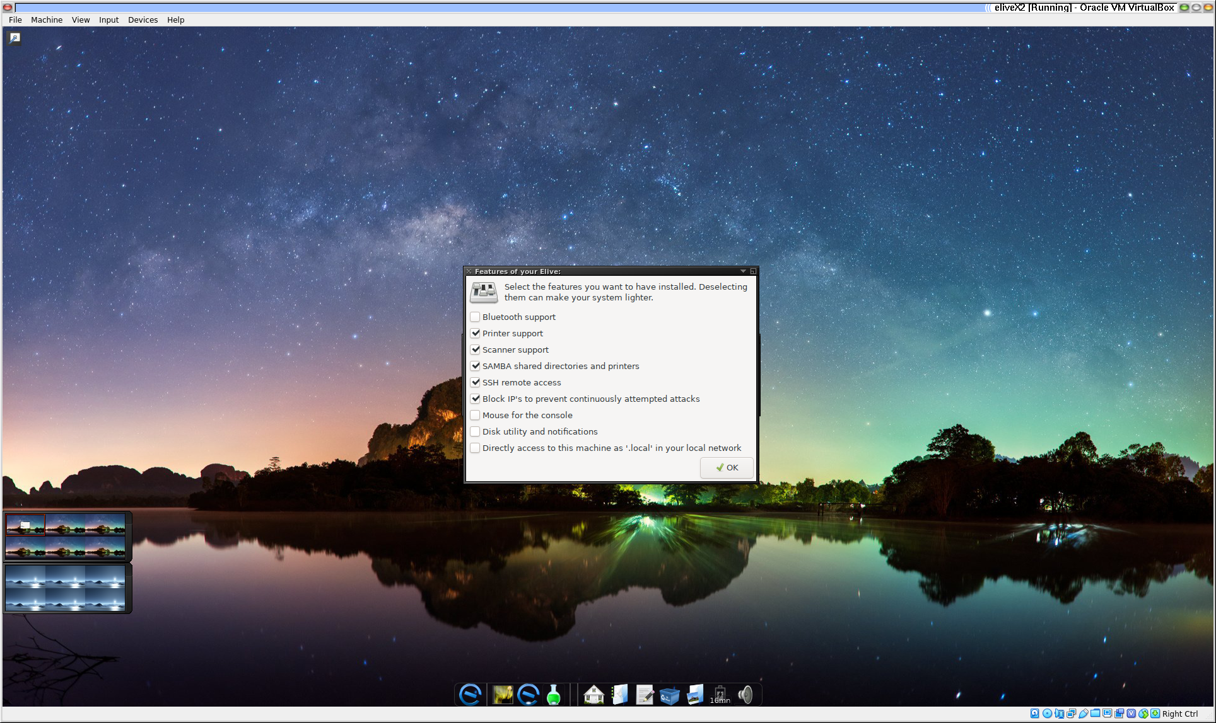
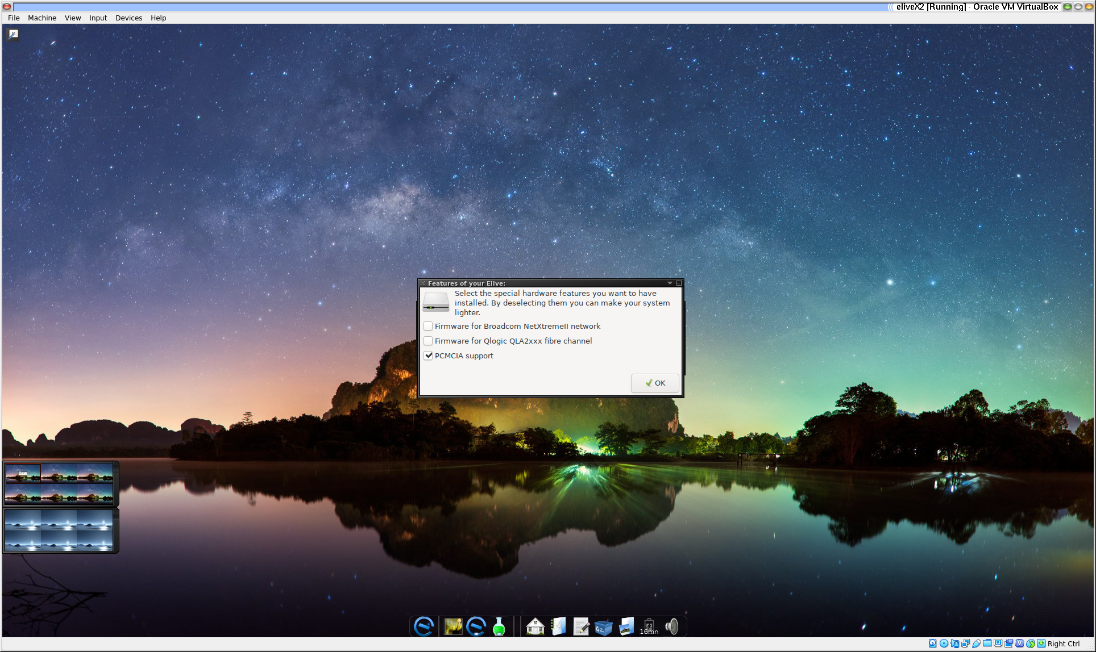
Which are fairly easy to answer.

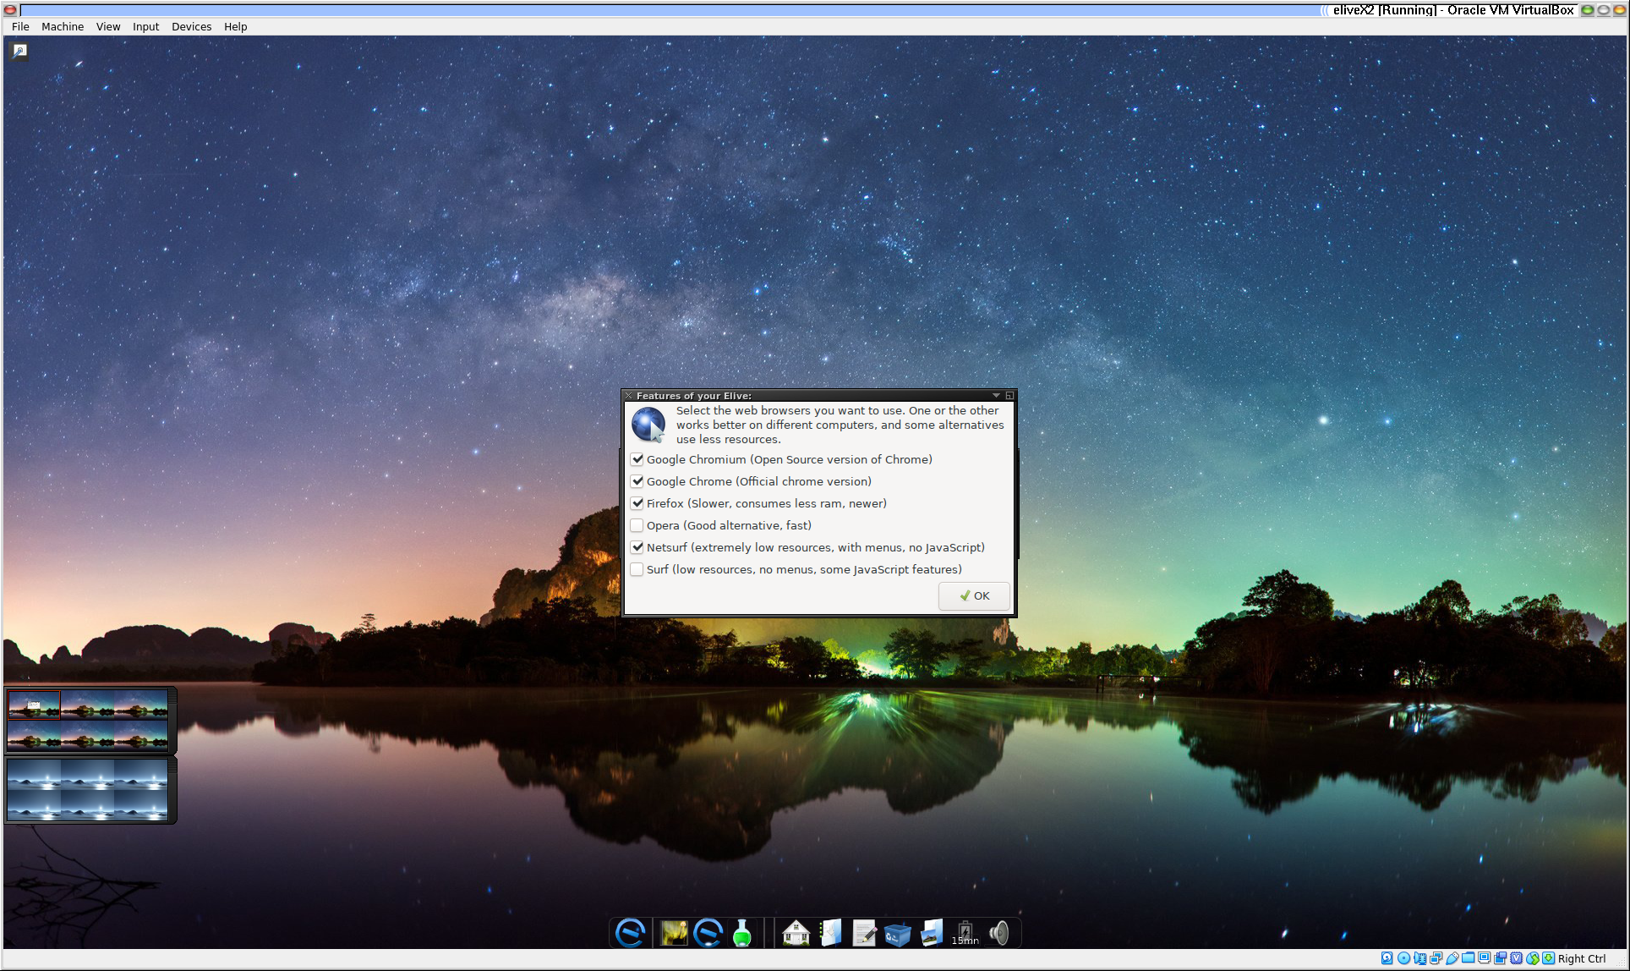
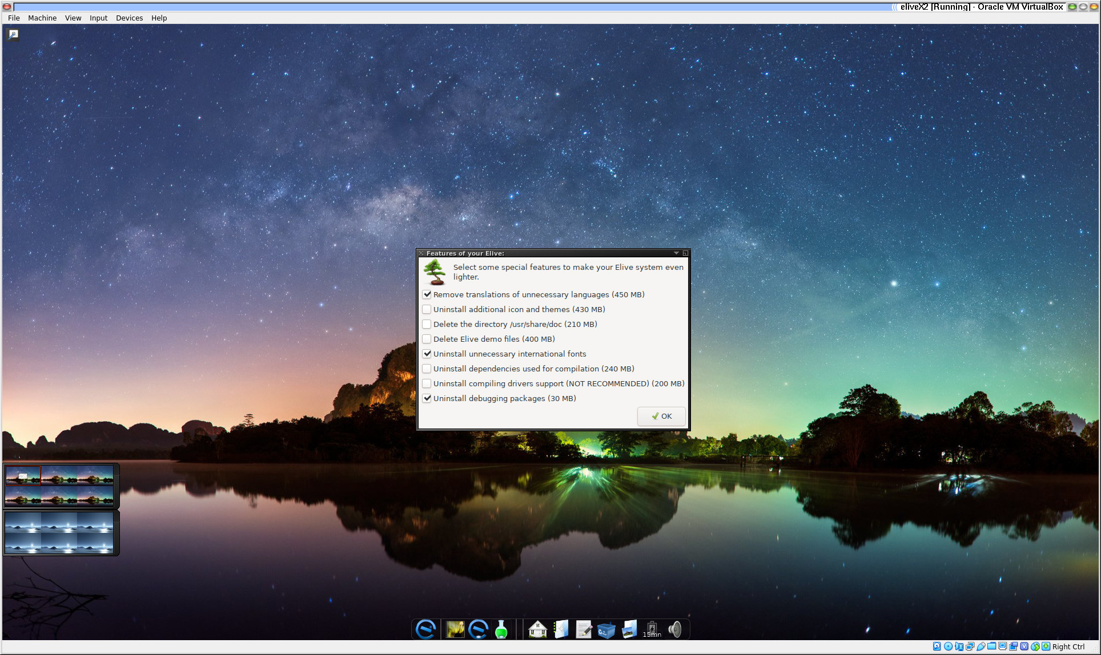
And self explanatory.

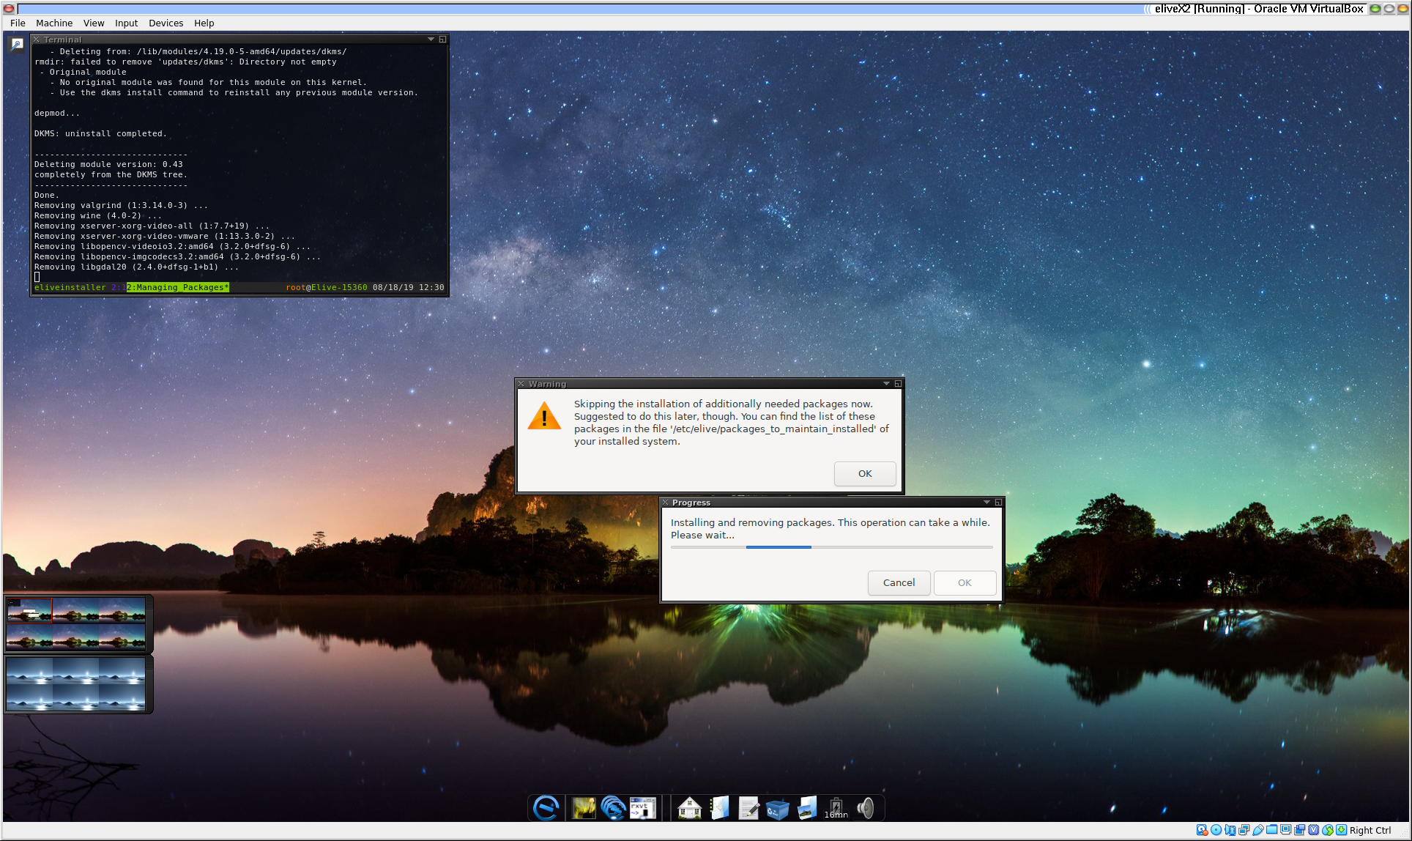
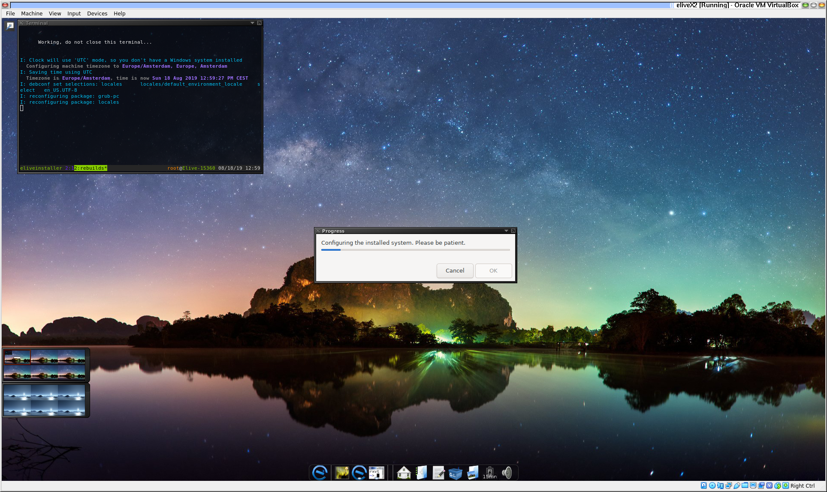
And a warning about the boot partition, of course.
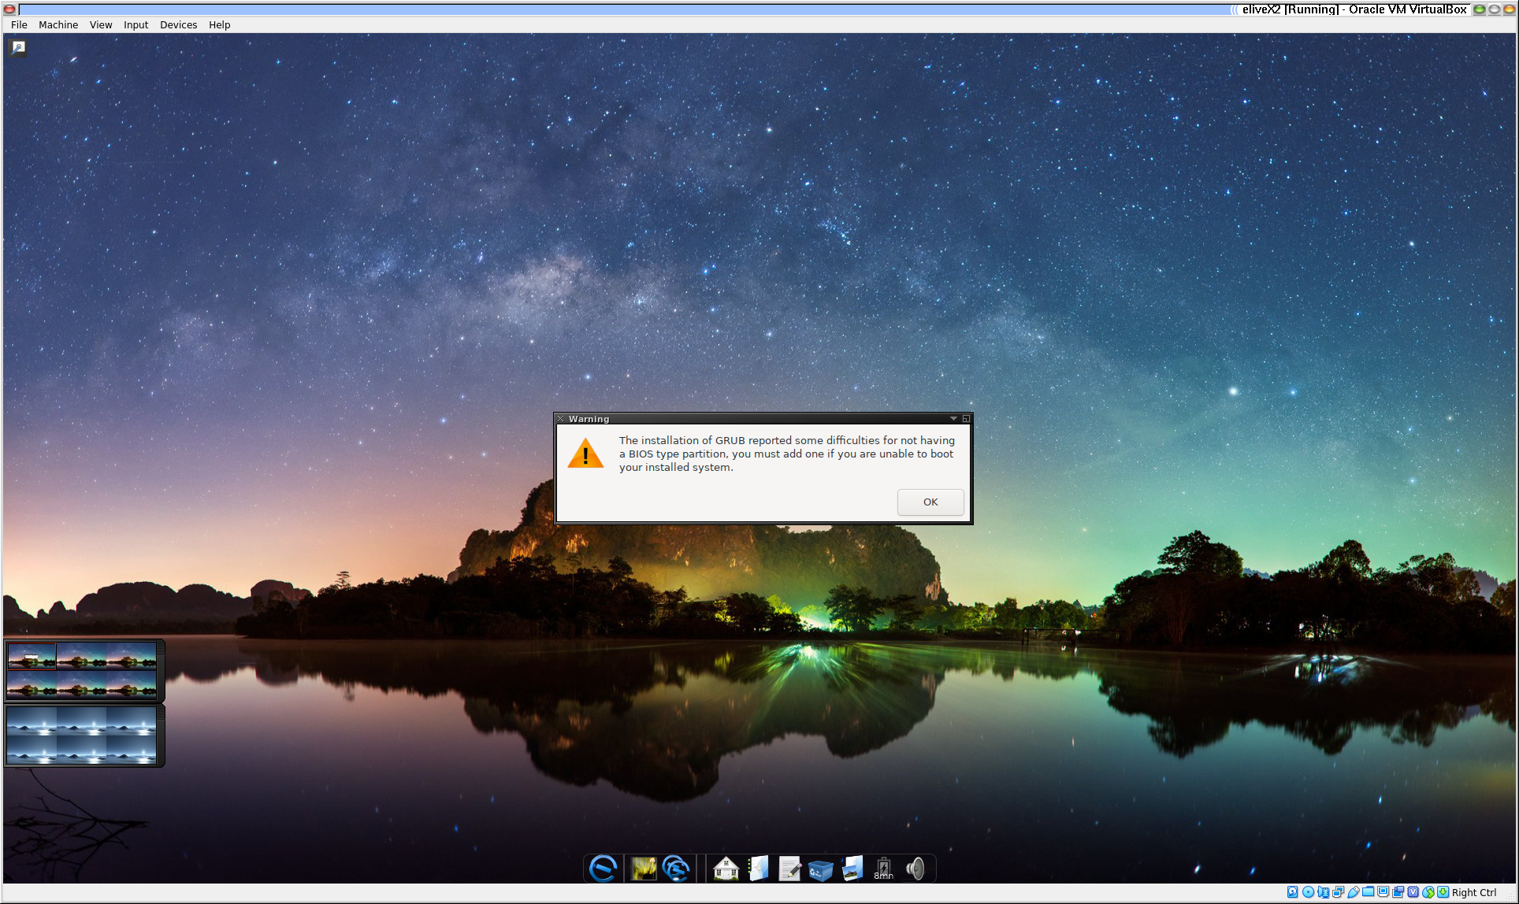
But a subsequent reboot gives exactly what was wanted in the first place.

Success!


